Nama : Adi Saepul Anwar
NPM : 43A87006200129
Matkul : Jarkom 2
Kelas : S1/TI/4/AM

Topologi

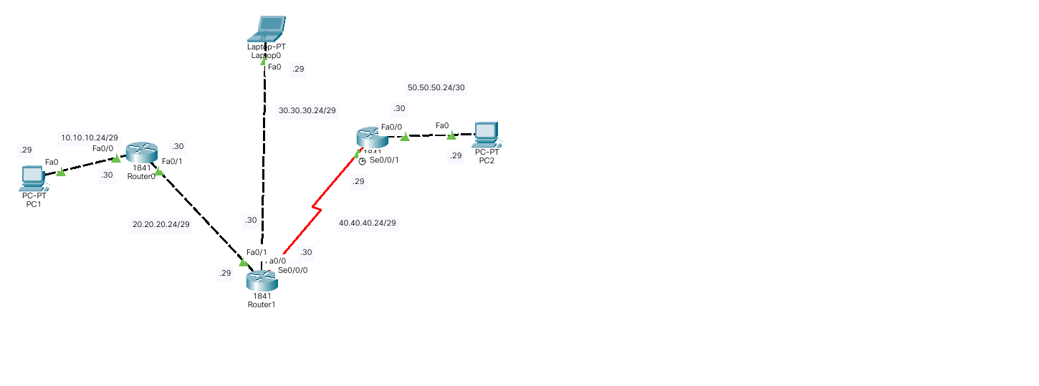

Konfigurasi
Router 0
interface FastEthernet0/0
ip address 10.10.10.30 255.255.255.248
duplex auto
speed auto
!
interface FastEthernet0/1
ip address 20.20.20.30 255.255.255.248
duplex auto
speed auto
!
interface Serial0/0/0
no ip address
clock rate 2000000
shutdown
!
interface Serial0/0/1
no ip address
clock rate 2000000
shutdown
!
interface Vlan1
no ip address
shutdown
!
router eigrp 200
network 10.10.10.0 0.0.0.255
network 20.20.20.0 0.0.0.127
network 10.10.10.24 0.0.0.7
network 20.20.20.24 0.0.0.7
auto-summary

Router 1
interface FastEthernet0/0
ip address 30.30.30.30 255.255.255.248
duplex auto
speed auto
!
interface FastEthernet0/1
ip address 20.20.20.29 255.255.255.248
duplex auto
speed auto
!
interface Serial0/0/0
ip address 40.40.40.30 255.255.255.248
!
interface Serial0/0/1
no ip address
clock rate 2000000
shutdown
!
interface Vlan1
no ip address
shutdown
!
router eigrp 200
network 20.20.20.0 0.0.0.127
network 30.30.30.0 0.0.0.255
network 40.40.40.0 0.0.0.255
network 20.20.20.24 0.0.0.7
network 30.30.30.24 0.0.0.7
network 40.40.40.24 0.0.0.7
auto-summary

Router 2
interface FastEthernet0/0
ip address 50.50.50.30 255.255.255.248
duplex auto
speed auto
!
interface FastEthernet0/1
no ip address
duplex auto
speed auto
shutdown
!
interface Serial0/0/0
no ip address
clock rate 2000000
shutdown
!
interface Serial0/0/1
ip address 40.40.40.29 255.255.255.248
clock rate 2000000
!
interface Vlan1
no ip address
shutdown
!
router eigrp 200
network 50.50.50.24 0.0.0.7
network 40.40.40.24 0.0.0.7
auto-summary
Table Routing

Router 0 | Router 1 | Router 2
Gateway of last resort is not set  10.0.0.0/8 is variably subnetted, 2 subnets, 2 masks  D 10.0.0.0/8 is a summary, 00:01:21, Null0  C 10.10.10.24/29 is directly connected, FastEthernet0/0  20.0.0.0/8 is variably subnetted, 2 subnets, 2 masks  D 20.0.0.0/8 is a summary, 00:01:21, Null0  C 20.20.20.24/29 is directly connected, FastEthernet0/1  D 30.0.0.0/8 [90/30720] via 20.20.20.29, 00:03:19, FastEthernet0/1  D 40.0.0.0/8 [90/2172416] via 20.20.20.29, 00:03:14, FastEthernet0/1  D 50.0.0.0/8 [90/2174976] via 20.20.20.29, 00:03:14, FastEthernet0/1 | Gateway of last resort is not set  D 10.0.0.0/8 [90/30720] via 20.20.20.30, 00:13:27, FastEthernet0/1  20.0.0.0/8 is variably subnetted, 2 subnets, 2 masks  D 20.0.0.0/8 is a summary, 00:32:00, Null0  C 20.20.20.24/29 is directly connected, FastEthernet0/1  30.0.0.0/8 is variably subnetted, 2 subnets, 2 masks  D 30.0.0.0/8 is a summary, 00:32:00, Null0  C 30.30.30.24/29 is directly connected, FastEthernet0/0  40.0.0.0/8 is variably subnetted, 2 subnets, 2 masks  D 40.0.0.0/8 is a summary, 00:30:40, Null0  C 40.40.40.24/29 is directly connected, Serial0/0/0  D 50.0.0.0/8 [90/2172416] via 40.40.40.29, 00:09:13, Serial0/0/0 | Gateway of last resort is not set  D 10.0.0.0/8 [90/2174976] via 40.40.40.30, 00:08:46, Serial0/0/1  D 20.0.0.0/8 [90/2172416] via 40.40.40.30, 00:08:46, Serial0/0/1  D 30.0.0.0/8 [90/2172416] via 40.40.40.30, 00:08:46, Serial0/0/1  40.0.0.0/8 is variably subnetted, 2 subnets, 2 masks  D 40.0.0.0/8 is a summary, 00:08:46, Null0  C 40.40.40.24/29 is directly connected, Serial0/0/1  50.0.0.0/8 is variably subnetted, 2 subnets, 2 masks  D 50.0.0.0/8 is a summary, 00:08:46, Null0  C 50.50.50.24/29 is directly connected, FastEthernet0/0

